Lab 5 ANOVA

Instructions

For this lab you need to install package {agricolae} and package {car}and then load library(agricolae) and library(car). All the data needed to answer the questions can be found in the excel sheet Lab 5 data, or in the CSV files. Question L5.1 goes with Lab 5.1.csv file.
If you downloaded perl on your computer you can use the read.xls function, otherwise you can use the read.csv function. Make sure you copy the data files to your working directory first.

L5.1 Uniformity of the etch
In “Orthogonal Design for Process Optimization and Its Application to Plasma Etching” (Solid State Technology, May 1987), G.Z. Yin and D.W. Jillie describe an experiment to determine the effect of C₂F₆ flow rate on uniformity of the etch on a silicon wafer used in integrated circuit manufacturing. Three flow rates are used in the experiment, and the resulting uniformity(%) for six replicates is shown below.

C₂F₆Flow (SCCM) | Observations
C₂F₆Flow (SCCM) | 1 | 2 | 3 | 4 | 5 | 6
125 | 2.7 | 4.6 | 2.6 | 3.0 | 3.2 | 3.8
160 | 4.9 | 4.6 | 5.0 | 4.2 | 3.6 | 4.2
200 | 4.6 | 3.4 | 2.9 | 3.5 | 4.1 | 5.1

- What would be an appropriate test to determine whether C₂F₆ flow rate affects etch uniformity?
1-way anova
- Construct a box plot of the three factor levels C₂F₆ flow rate
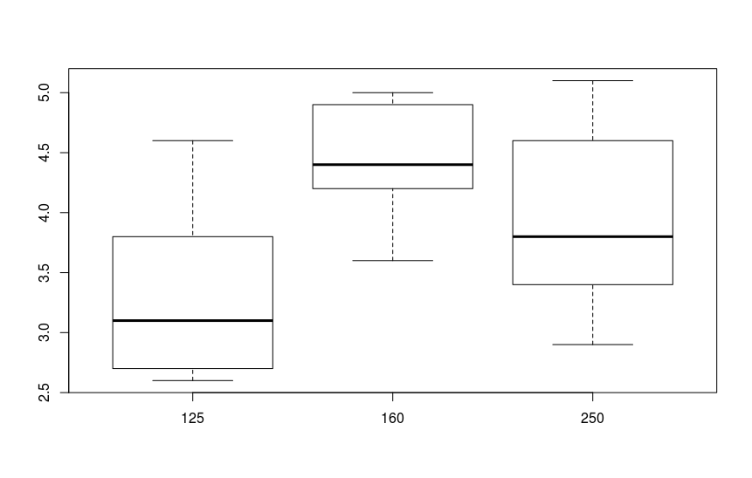
- Test for homogeneity of variance using the levene test function. Can we assume equal variance?
Code:
setwd("~/Downloads/statistics-2-datasets/lab 5/")
library(agricolae)
library(car)

library(gdata) # activate library
mydata = read.csv("Lab 5.1.csv", header = FALSE, sep = ";") # import the file in dataframe
v1 <- mydata$V1
v2 <- mydata$V2

cat("====================", "\n")
cat("== L5.1", "\n")
cat("====================", "\n")

# A
# print(mydata)

# B
boxplot(v2~factor(v1))

# C
print(
bartlett.test(
v2~factor(v1)
)
)

Output:
====================
== L5.1
====================

Bartlett test of homogeneity of variances

data: v2 by factor(v1)
Bartlett's K-squared = 0.96544, df = 2, p-value = 0.6171

Conclusion:
The p-value of the Bartlett test is > 0.05. This means that the p-value is high, so the variances are not equal (reject H0).

- Test the hypothesis that C₂F₆ flow rate affects the uniformity, use alpha 0.05.
State your conclusion in words.
Code:
setwd("~/Downloads/statistics-2-datasets/lab 5/")
library(agricolae)
library(car)

library(gdata) # activate library
mydata = read.csv("Lab 5.1.csv", header = FALSE, sep = ";") # import the file in dataframe
v1 <- mydata$V1
v2 <- mydata$V2

cat("====================", "\n")
cat("== L5.1", "\n")
cat("====================", "\n")

# A
# print(mydata)

# B
boxplot(v2~factor(v1))

# C
# print(
# bartlett.test(
# v2~factor(v1)
# )
# )

# D
data = data.frame(y = v2, x = factor(v1))
model = lm(v2 ~ factor(v1), data = data)
print(
# summary(
oneway.test(v2 ~ factor(v1), data)
# )
)
Output:
====================
== L5.1
====================

One-way analysis of means (not assuming equal variances)

data: v2 and factor(v1)
F = 4.0411, num df = 2.00, denom df = 9.57, p-value = 0.05342

Conclusion:
The p-value is > alpha of 0.05. This means that H0 can be rejected (the factor doesn't have an influence) and Ha can be accepted (the factor does have an influence).
- Plot the residuals.
- Do the residuals indicate any problems with the underlying assumptions or are the residuals acceptable?

L5.2 Coating type affect on conductivity
An electronic engineer is interested in the effect on tube conductivity of five different types of coating for cathode ray tubes in telecommunication system display device. The following conductivity data are obtained.

Coating type | Conductivity
1 | 145 | 141 | 148 | 146
2 | 150 | 149 | 137 | 143
3 | 134 | 133 | 132 | 127
4 | 129 | 127 | 132 | 132
5 | 147 | 150 | 144 | 139

- What would be an appropriate test to determine whether coating type affects the conductivity?
- Construct a box plot of the 5 levels coating type. Which of the coating types do you think differ from the others?
- Test if there is a difference in conductivity due to coating type using alpha = 0.05. Assume equal variance. Write your conclusion.
- Analyse the residuals of this experiment
- In case of a difference test which coating type makes a significant difference? Use the post hoc tests LSD and tukeyHSD to find out which type differs significant from the others.
- If there is an effect, how big is this effect? Use eta2 to quantify the relation.

L5.3 Contact resistance
An article in the IEEE Transactions for components, Hybrids, and Manufacturing Technology (Vol. 15, No. 2, 1992, pp. 146-153) describes an experiment in which contact resistance of a brake-only relay was studied for three different materials (all were silver-based alloys) the data are as follows:

Alloy | Contact Resistance
1 | 95 | 97 | 99 | 98 | 99
 | 99 | 99 | 94 | 95 | 98
2 | 104 | 102 | 102 | 105 | 99
 | 102 | 111 | 103 | 100 | 103
3 | 119 | 130 | 132 | 136 | 141
 | 172 | 145 | 150 | 144 | 135

- Test for homogeneity using levene’s test.
- What would be an appropriate hypothesis test to determine whether the type of alloy affects the mean contact resistance?
- Make a boxplot of the different alloy types. Can we assume equal variance and mean?
- Test the hypothesis. Use alpha is 0.01
- Use Fisher’s LSD method to determine which means differ, use alpha = 0.01
- Which alloy would you recommend?

L5.4 Investigation of voltage leakage
An experiment was conducted to investigate leaking current in a SOS MOSFETS device. The purpose of the experiment was to investigate how leakage current varies as the channel length changes. Four channel lengths were selected. For each channel length, five different widths were also used. The data are as follow:

Channel length | Width
Channel length | 1 | 2 | 3 | 4
1 | 0.7 | 0.8 | 0.7 | 1.0
2 | 0.8 | 0.8 | 0.9 | 1.0
3 | 0.9 | 1.0 | 1.7 | 4.0
4 | 1.0 | 1.6 | 2.0 | 20.0

- What would be an appropriate test to the hypothesis that mean leakage voltage does not depend on channel length or channel width?
- Make a nice plot representing the results in a cube. (see references below)
- Test the hypothesis. Use alpha = 0.05.
- Analyse the residuals of this experiment. Comment on the residuals plot.
- The observed leakage voltage for channel length 4 and width 5 was erroneously recorded. The correct observation is 4.0. Analyse the corrected data from this experiment. Is there evidence to conclude that mean leakage voltage increases with channel length?
- What is the practical significance of width and length? Use eta-squared (SSfactor / SStotal) to estimate the practical significance.
- Use the interaction.plot() function to compose an interaction plot. Which channel length and width would you recommend the engineer?
- Do you think the anova model can be improved?

https://cran.r-project.org/web/packages/scatterplot3d/vignettes/s3d.pdf
http://www.statmethods.net/graphs/scatterplot.html

